
Test 4

Logarithmic Functions

Semester One 2018
Year 12 Mathematics Methods
Calculator Assumed
Name:

Date: 29/06/2018 7.45am
You may have a calculator, a single-sided page of notes and a formula sheet for the test.
40 Minutes Total___________/35 marks



Questions 1 (7 marks)
Find the derivatives of the following. Do not simplify your answer.
- ${\ln\left(2x^{3}-3x^{2}+4x-1\right)}^{3}$ (2 marks)

- $e^{x} ln⁡(x)$ (2 marks)

- $\ln\left(x\right)\cos\left(x\right)+\frac{\sin\left(x\right)}{x}$ (3 marks)

Question 2 (5 marks)
- Use Polynomial Long division to simplify $\frac{x^{2}- 2x + 5}{x - 3}$. (3 marks)

- Hence find $∫\frac{x^{2} - 2x + 5}{x - 3} dx.$ (2 marks)

Question 3 (5 marks)
- Find the constants $a$ and $b$ given that for {$x ∈R:x ≠2, x≠ -3\}$. (3 marks)
$$\frac{a}{x-2}+\frac{b}{x+3}=\frac{x+8}{x^{2}+x-6}$$

- Hence find $\int{\frac{x + 8}{{x }^{2 }+ x - 6} dx.}$ (2 marks)

Question 4 (2 marks)
The rule for the function shown is $y=ln (x-m)+n$. Find the values of $m$ and $n.$
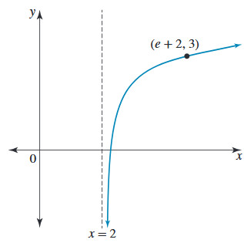

Question 5 (3 marks)
Solve the following equations for $x$. Show full algebraic reasoning.
$$3e^{2x}-5e^{x}-2=0$$

Question 6 (5 marks)
The graph of the function with the rule $y=3\log\left(x+1\right)+2$ intersects the axes at the point $(a,0)$ and $(0,b$). Find the exact values of $a$ and $b.$ Show full algebraic reasoning.

Question 7 (8 marks)
There are two species of insects living in a suburb: the Asla bibla and the Cutus pius. The number of Ala bibla alive at time $t$ days after 1 January 2000 is given by
$$N_{A}\left(t\right)=10 000+1000t, 0≤t≤15$$
The number of Cutus pius alive at time $t$ days after 1 January 2000 is given by
$$N_{C}\left(t\right)=8000+3×2^{t}, 0≤t≤15$$
- (i) Show full reasoning that $N_{A}\left(t\right)=N_{C}\left(t\right)$ if and only if $t=3\log_{2}10+ \log_{2}\left(\frac{2 + t}{3}\right).$ (4 marks)

- Solve the value for $t$ if $t=3\log_{2}10+ \log_{2}\left(\frac{2 + t}{3}\right).$ (2 marks)

- It is found by observation that the model for Cutus pius does not quite work. It is known that the model for the population of Asla bible is satisfactory. The form of the model for Cutus pius is $N_{C}\left(t\right)=8000+c×2^{t}$. Find the value of $c$, correct to two decimal places, if it is known that $N_{A}\left(15\right)= N_{C}\left(15\right).$ (2 marks)

End of Test

